EXERCISE 15 REACTJS-HOL

Explain about React Forms
React forms are used to collect user input within a component. Unlike HTML forms where form data is managed by the DOM, React takes control of form elements by storing their values in the component’s state. This allows for more control over user input, validation, and dynamic form behavior. React supports form elements like input, textarea, select, etc., and updates the UI in response to user interactions through state changes.

Define Controlled Components
In React, a controlled component is a form element (like <input>, <textarea>, or <select>) whose value is controlled by the component’s state. Instead of relying on the DOM to manage input values, React sets the input value using state and updates it through an onChange handler. This allows the developer to maintain a single source of truth for form data, enabling validation, conditional rendering, and dynamic updates easily.

Explain about Various Input Controls
React supports various input controls including:
- Text Input (<input type="text" />) for single-line text,
- Textarea (<textarea>) for multi-line input,
- Checkboxes (<input type="checkbox" />) for boolean options,
- Radio Buttons (<input type="radio" />) for selecting one option from many,
- Select Dropdowns (<select>) for drop-down menus.
Each of these inputs can be made controlled by linking them to state variables and updating them with onChange event handlers.

Explain about Handling Forms
Handling forms in React involves creating state variables to store the input values, updating those variables using onChange handlers, and possibly validating inputs in real time. Each input field should be linked to a corresponding state variable, and its value should be updated using a handler function. This approach ensures that all form data is stored in React's state and is fully controllable from the component.

Explain about Submitting Forms
Form submission in React is typically handled using the onSubmit event of the <form> tag. A function is defined to handle the form submission, which often includes calling event.preventDefault() to stop the page from refreshing and processing the form data stored in state. This is where you typically validate the form, send data to a server, or perform other actions like clearing the form or displaying messages.

HANDS-ON EXERCISE:
STRUCTURE:
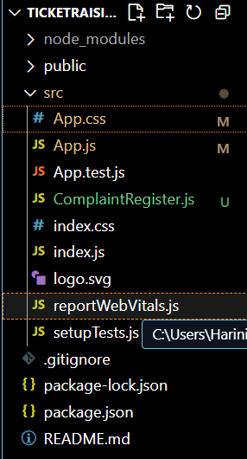

CODE:
App.js
import React from 'react';
import ComplaintRegister from './ComplaintRegister';
import './App.css';

function App() {
return (
<div className="App">
<h1>Register your complaints here!!!</h1>
<ComplaintRegister />
</div>
);
}

export default App;

ComplaintRegister.js
import React from 'react';

class ComplaintRegister extends React.Component {
constructor(props) {
super(props);
this.state = {
ename: '',
complaint: '',
numberHolder: ''
};
}

handleChange = (event) => {
this.setState({ [event.target.name]: event.target.value });
}

handleSubmit = (event) => {
const refNumber = Math.floor(100000 + Math.random() * 900000); // 6-digit ref number
this.setState({ numberHolder: refNumber });

const msg = `Thanks ${this.state.ename}\nYour Complaint was Submitted\nReference ID: ${refNumber}`;
alert(msg);

event.preventDefault();
}

render() {
return (
<form onSubmit={this.handleSubmit}>
<div>
<label>Name: </label><br />
<input
type="text"
name="ename"
value={this.state.ename}
onChange={this.handleChange}
required
/>
</div>

<div>
<label>Complaint:</label><br />
<textarea
name="complaint"
value={this.state.complaint}
onChange={this.handleChange}
rows="5"
cols="40"
required
/>
</div>

<div>
<button type="submit">Submit</button>
</div>
</form>
);
}
}

export default ComplaintRegister;

App.css
.App {
font-family: Arial, sans-serif;
text-align: center;
margin-top: 50px;
}

form {
background-color: #f2f2f2;
padding: 20px;
margin: 0 auto;
width: 350px;
border-radius: 8px;
box-shadow: 0 0 10px #aaa;
}

input, textarea {
width: 100%;
padding: 8px;
margin-top: 10px;
margin-bottom: 20px;
border-radius: 4px;
border: 1px solid #ccc;
}

button {
background-color: #007bff;
color: white;
padding: 10px 25px;
border: none;
border-radius: 5px;
cursor: pointer;
}
button:hover {
background-color: #0056b3;
}

OUTPUT:
